EXERCISE 16
1.List IDs, birth dates, and emails of employees born in April.
SELECT employee_id, birth_date, email FROM employee_data WHERE MONTHNAME(birth_date) = 'April';
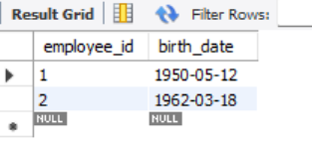

2.Display IDs, birth dates, and spouse names of employees born in 1969,and sort by spouse name.
SELECT employee_id, birth_date, spouse_name FROM employee_data WHERE YEAR(birth_date) = 1969 ORDER BY spouse_name;
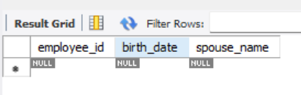

3.List employee IDs for employees born under the current month.
SELECT employee_id FROM employee_data WHERE MONTH(birth_date) = MONTH(CURRENT_DATE);
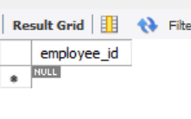

4.How many unique birth years do we have?
SELECT COUNT(DISTINCT YEAR(birth_date)) AS 'Unique Birth Years' FROM employee_data;
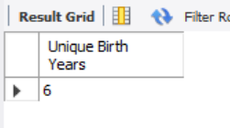

5.Display a list of unique birth years and the number of employees born each year.
SELECT YEAR(birth_date) AS 'Birth Year', COUNT(*) AS 'Number of Employees' FROM employee_data GROUP BY YEAR(birth_date);
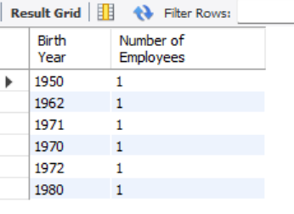

6.How many employees were born under each month?Display month names (not numbers), and sort so that the month with the most births is shown first.
SELECT MONTHNAME(birth_date) AS 'Month', COUNT(*) AS 'Number of Employees' FROM employee_data GROUP BY MONTHNAME(birth_date) ORDER BY COUNT(*) DESC;
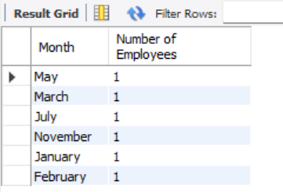

CREATE DATABASE EXERCISE16_ADDRESSBOOK;
USE EXERCISE16_ADDRESSBOOK;
CREATE TABLE employee_data (
employee_id INT AUTO_INCREMENT PRIMARY KEY,
f_name VARCHAR(100),
l_name VARCHAR(100),
birth_date DATE,
email VARCHAR(150),
spouse_name VARCHAR(100),
marital_status CHAR(1),
children INT,
sex CHAR(1)
);
INSERT INTO employee_data (f_name, l_name, birth_date, email, spouse_name, marital_status, children, sex) VALUES
('Kim', 'Mariano', '1950-05-12', 'kim.mariano@email.com', 'Maria Santos', 'Y', 3, 'M'),
('Trisha', 'Kim', '1962-03-18', 'trisha.kim@email.com', 'Ana Lopez', 'Y', 2, 'F'),
('Kim', 'Etucag', '1971-07-22', 'kim.etucag@email.com', 'Liza Dizon', 'Y', 1, 'M'),
('Daniel', 'Aguilar', '1970-11-10', 'daniel.aguilar@email.com', NULL, 'N', 0, 'M'),
('Mariel', 'Blue', '1972-01-29', 'mariel.blue@email.com', NULL, 'N', 1, 'F'),
('Hazel', 'Tolentino', '1980-02-14', 'hazel.tolentino@email.com', 'Jenny Garcia', 'Y', 2, 'F');

SELECT employee_id, birth_date, email FROM employee_data WHERE MONTHNAME(birth_date) = 'April';
SELECT employee_id, birth_date, spouse_name FROM employee_data WHERE YEAR(birth_date) = 1969 ORDER BY spouse_name;
SELECT employee_id FROM employee_data WHERE MONTH(birth_date) = MONTH(CURRENT_DATE);
SELECT COUNT(DISTINCT YEAR(birth_date)) AS 'Unique Birth Years' FROM employee_data;
SELECT YEAR(birth_date) AS 'Birth Year', COUNT(*) AS 'Number of Employees' FROM employee_data GROUP BY YEAR(birth_date);

